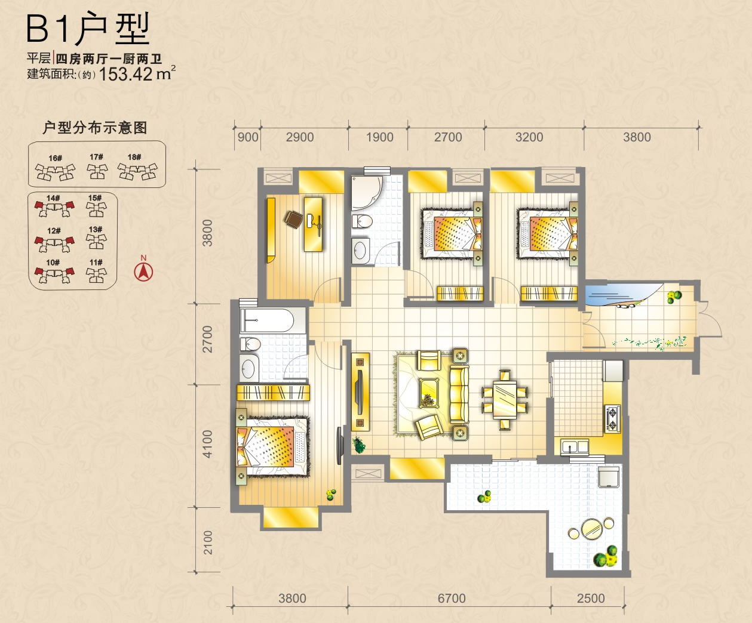
10号楼 |  | 12号楼 |  | 14号楼
 |  |  |  | 14-A-2101 | 14-B-2101
 |  |  |  | 14-A-2001 | 14-B-2001
 |  | 12-A-1901 | 12-B-1901 | 14-A-1901 | 14-B-1901
 |  | 12-A-1801 | 12-B-1801 | 14-A-1801 | 14-B-1801
10-A-1701 | 10-B-1701 | 12-A-1701 | 12-B-1701 | 14-A-1701 | 14-B-1701
10-A-1601 | 10-B-1601 | 12-A-1601 | 12-B-1601 | 14-A-1601 | 14-B-1601
10-A-1501 | 10-B-1501 | 12-A-1501 | 12-B-1501 | 14-A-1501 | 14-B-1501
10-A-1401 | 10-B-1401 | 12-A-1401 | 12-B-1401 | 14-A-1401 | 14-B-1401
10-A-1301 | 10-B-1301 | 12-A-1301 | 12-B-1301 | 14-A-1301 | 14-B-1301
10-A-1201 | 10-B-1201 | 12-A-1201 | 12-B-1201 | 14-A-1201 | 14-B-1201
10-A-1101 | 10-B-1101 | 12-A-1101 | 12-B-1101 | 14-A-1101 | 14-B-1101
10-A-1001 | 10-B-1001 | 12-A-1001 | 12-B-1001 | 14-A-1001 | 14-B-1001
10-A-901 | 10-B-901 | 12-A-901 | 12-B-901 | 14-A-901 | 14-B-901
10-A-801 | 10-B-801 | 12-A-801 | 12-B-801 | 14-A-801 | 14-B-801
10-A-701 | 10-B-701 | 12-A-701 | 12-B-701 | 14-A-701 | 14-B-701
10-A-601 | 10-B-601 | 12-A-601 | 12-B-601 | 14-A-601 | 14-B-601
10-A-501 | 10-B-501 | 12-A-501 | 12-B-501 | 14-A-501 | 14-B-501
10-A-401 | 10-B-401 | 12-A-401 | 12-B-401 | 14-A-401 | 14-B-401
10-A-301 | 10-B-301 | 12-A-301 | 12-B-301 | 14-A-301 | 14-B-301
10-A-201 | 10-B-201 | 12-A-201 | 12-B-201 | 14-A-201 | 14-A-201
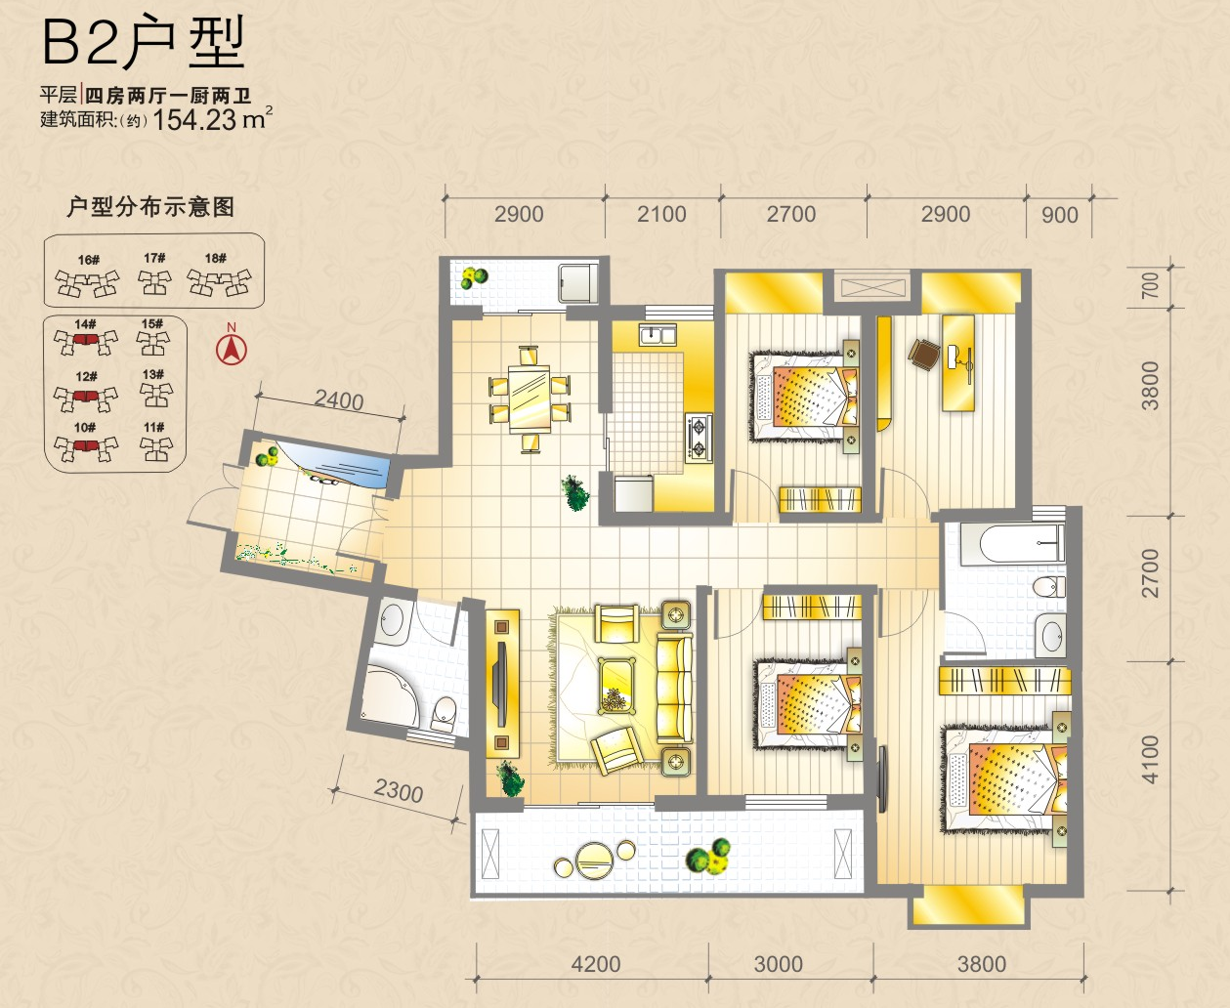
10号楼 |  | 12号楼 |  | 14号楼
 |  |  |  | 14-A-2102 | 14-B-2102
 |  |  |  | 14-A-2002 | 14-B-2002
 |  | 12-A-1902 | 12-B-1902 | 14-A-1902
 |  | 12-A-1802 | 12-B-1802 | 14-A-1802
10-A-1702 | 10-B-1702 | 12-A-1702 | 12-B-1702 | 14-A-1702
10-A-1602 | 10-B-1602 | 12-A-1602 | 12-B-1602 | 14-A-1602
10-A-1502 | 10-B-1502 | 12-A-1502 | 12-B-1502 | 14-A-1502
10-A-1402 | 10-B-1402 | 12-A-1402 | 12-B-1402 | 14-A-1402
10-A-1302 | 10-B-1302 | 12-A-1302 | 12-B-1302 | 14-A-1302
10-A-1202 | 10-B-1202 | 12-A-1202 | 12-B-1202 | 14-A-1202
10-A-1102 | 10-B-1102 | 12-A-1102 | 12-B-1102 | 14-A-1102
10-A-1002 | 10-B-1002 | 12-A-1002 | 12-B-1002 | 14-A-1002
10-A-902 | 10-B-902 | 12-A-902 | 12-B-902 | 14-A-902
10-A-802 | 10-B-802 | 12-A-802 | 12-B-802 | 14-A-802
10-A-702 | 10-B-702 | 12-A-702 | 12-B-702 | 14-A-702
10-A-602 | 10-B-602 | 12-A-602 | 12-B-602 | 14-A-602
10-A-502 | 10-B-502 | 12-A-502 | 12-B-502 | 14-A-502
10-A-402 | 10-B-402 | 12-A-402 | 12-B-402 | 14-A-402
10-A-302 | 10-B-302 | 12-A-302 | 12-B-302 | 14-A-302
10-A-202 | 10-B-202 | 12-A-202 | 12-B-202 | 14-A-202

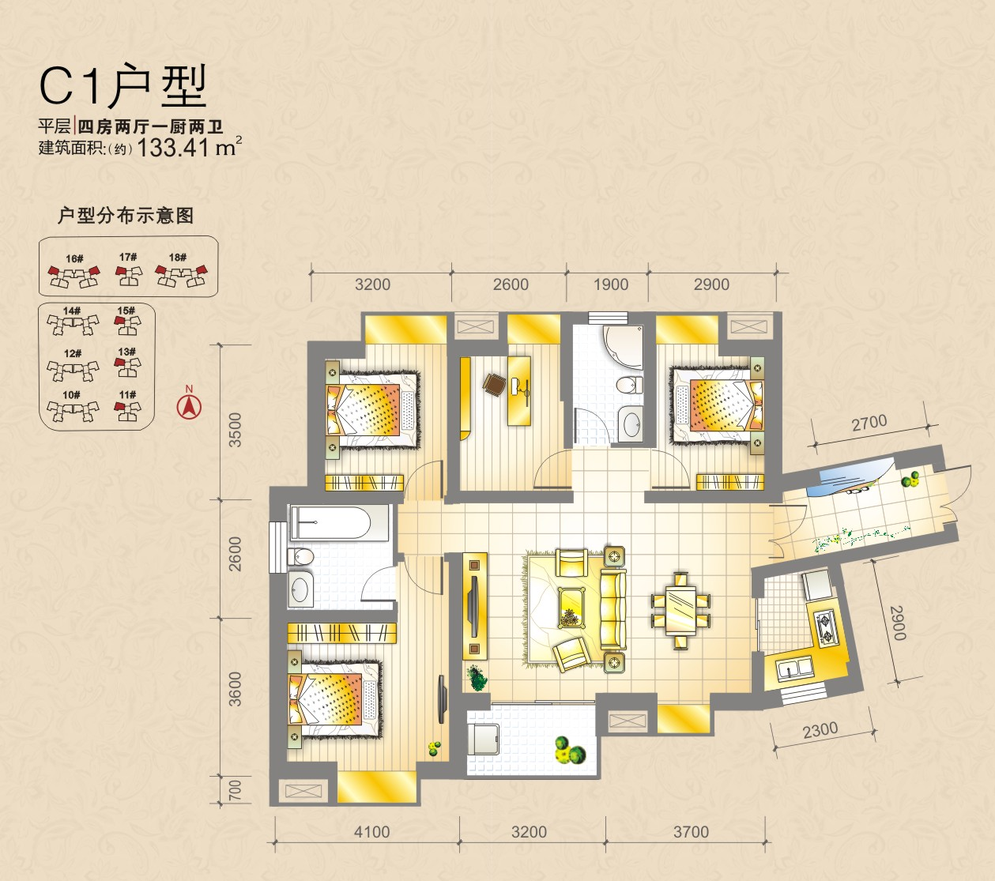
11号楼 | 13号楼 | 15号楼 | 16号楼 |  | 17号楼 | 18号楼
11-2501 | 13-2501 | 15-2501 |  | 16-B-2501 | 17-2501 | 18-A-2501 | 18-B-2501
11-2401 | 13-2401 | 15-2401 |  | 16-B-2401 | 17-2401 | 18-A-2401 | 18-B-2401
11-2301 | 13-2301 | 15-2301 |  | 16-B-2301 | 17-2301 | 18-A-2301 | 18-B-2301
11-2201 | 13-2201 | 15-2201 |  | 16-B-2201 | 17-2201 | 18-A-2201 | 18-B-2201
11-2101 | 13-2101 | 15-2101 |  | 16-B-2101 | 17-2101 | 18-A-2101 | 18-B-2101
11-2001 | 13-2001 | 15-2001 |  | 16-B-2001 | 17-2001 | 18-A-2001 | 18-B-2001
11-1901 | 13-1901 | 15-1901 |  | 16-B-1901 | 17-1901 | 18-A-1901 | 18-B-1901
11-1801 | 13-1801 | 15-1801 |  | 16-B-1801 | 17-1801 | 18-A-1801 | 18-B-1801
11-1701 | 13-1701 | 15-1701 |  | 16-B-1701 | 17-1701 | 18-A-1701 | 18-B-1701
11-1601 | 13-1601 | 15-1601 |  | 16-B-1601 | 17-1601 | 18-A-1601 | 18-B-1601
11-1501 | 13-1501 | 15-1501 |  | 16-B-1501 | 17-1501 | 18-A-1501 | 18-B-1501
11-1401 | 13-1401 | 15-1401 |  | 16-B-1401 | 17-1401 | 18-A-1401 | 18-B-1401
11-1301 | 13-1301 | 15-1301 | 1 | 16-B-1301 | 17-1301 | 18-A-1301 | 18-B-1301
11-1201 | 13-1201 | 15-1201 |  | 16-B-1201 | 17-1201 | 18-A-1201 | 18-B-1201
11-1101 | 13-1101 | 15-1101 |  | 16-B-1101 | 17-1101 | 18-A-1101 | 18-B-1101
11-1001 | 13-1001 | 15-1001 |  | 16-B-1001 | 17-1001 | 18-A-1001 | 18-B-1001
11-901 | 13-901 | 15-901 |  | 16-B-901 | 17-901 | 18-A-901 | 18-B-901
11-801 | 13-801 | 15-801 |  | 16-B-801 | 17-801 | 18-A-801 | 18-B-801
11-701 | 13-701 | 15-701 |  | 16-B-701 | 17-701 | 18-A-701 | 18-B-701
11-601 | 13-601 | 15-601 |  | 16-B-601 | 17-601 | 18-A-601 | 18-B-601
11-501 | 13-501 | 15-501 |  | 16-B-501 | 17-501 | 18-A-501 | 18-B-501
11-401 | 13-401 | 15-401 |  | 16-B-401 | 17-401 | 18-A-401 | 18-B-401
11-301 | 13-301 | 15-301 |  | 16-B-301 | 17-301 | 18-A-301 | 18-B-301
11-201 | 13-201 | 15-201 |  | 16-B-201 | 17-201 | 18-A-201 | 18-B-201

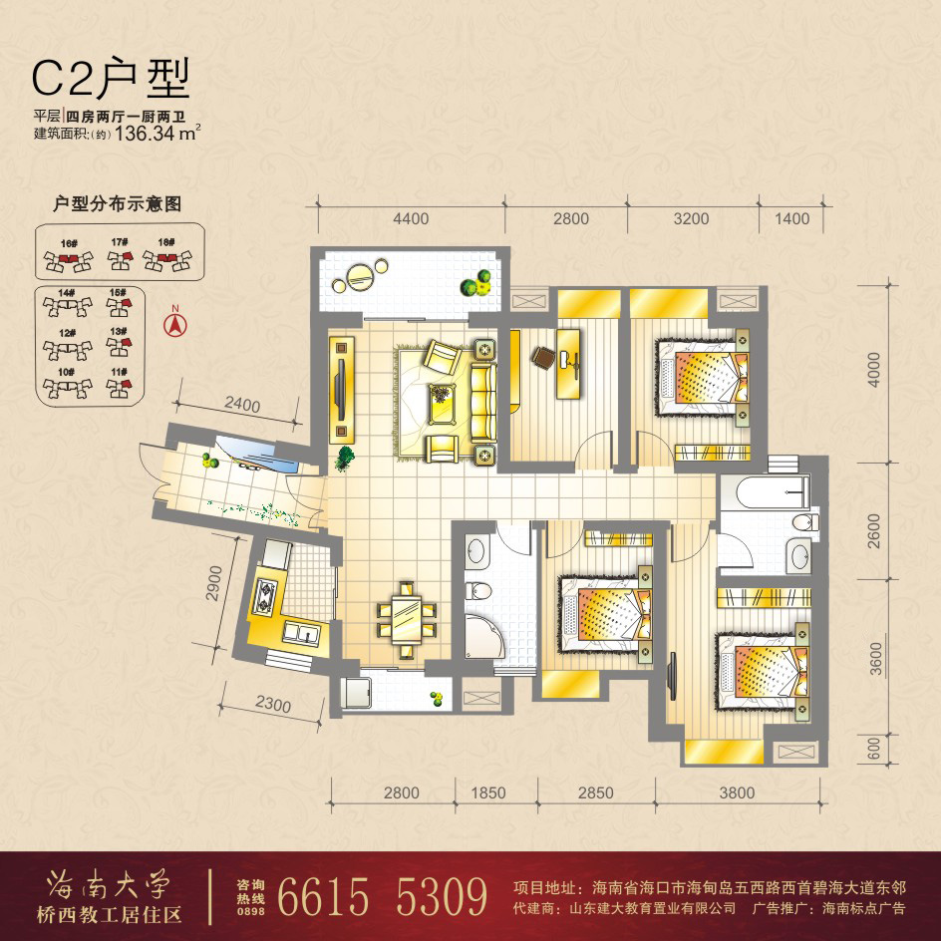
11号楼 | 13号楼 | 15号楼 | 16号楼 |  | 17号楼 | 18号楼
11-2502 | 13-2502 | 15-2502 |  | 16-B-2502 | 17-2502 | 18-A-2502 | 18-B-2502
11-2402 | 13-2402 | 15-2402 |  | 16-B-2402 | 17-2402 | 18-A-2402 | 18-B-2402
11-2302 | 13-2302 | 15-2302 |  | 16-B-2302 | 17-2302 | 18-A-2302 | 18-B-2302
11-2202 | 13-2202 | 15-2202 |  | 16-B-2202 | 17-2202 | 18-A-2202 | 18-B-2202
11-2102 | 13-2102 | 15-2102 |  | 16-B-2102 | 17-2102 | 18-A-2102 | 18-B-2102
11-2002 | 13-2002 | 15-2002 |  | 16-B-2002 | 17-2002 | 18-A-2002 | 18-B-2002
11-1902 | 13-1902 | 15-1902 |  | 16-B-1902 | 17-1902 | 18-A-1902 | 18-B-1902
11-1802 | 13-1802 | 15-1802 |  | 16-B-1802 | 17-1802 | 18-A-1802 | 18-B-1802
11-1702 | 13-1702 | 15-1702 |  | 16-B-1702 | 17-1702 | 18-A-1702 | 18-B-1702
11-1602 | 13-1602 | 15-1602 |  | 16-B-1602 | 17-1602 | 18-A-1602 | 18-B-1602
11-1502 | 13-1502 | 15-1502 |  | 16-B-1502 | 17-1502 | 18-A-1502 | 18-B-1502
11-1402 | 13-1402 | 15-1402 |  | 16-B-1402 | 17-1402 | 18-A-1402 | 18-B-1402
11-1302 | 13-1302 | 15-1302 |  | 16-B-1302 | 17-1302 | 18-A-1302 | 18-B-1302
11-1202 | 13-1202 | 15-1202 |  | 16-B-1202 | 17-1202 | 18-A-1202 | 18-B-1202
11-1102 | 13-1102 | 15-1102 |  | 16-B-1102 | 17-1102 | 18-A-1102 | 18-B-1102
11-1002 | 13-1002 | 15-1002 |  | 16-B-1002 | 17-1002 | 18-A-1002 | 18-B-1002
11-902 | 13-902 | 15-902 | 16-A-902 | 16-B-902 | 17-902 | 18-A-902 | 18-B-902
11-802 | 13-802 | 15-802 | 16-A-802 | 16-B-802 | 17-802 | 18-A-802 | 18-B-802
11-702 | 13-702 | 15-702 | 16-A-702 | 16-B-702 | 17-702 | 18-A-702 | 18-B-702
11-602 | 13-602 | 15-602 | 16-A-602 | 16-B-602 | 17-602 | 18-A-602 | 18-B-602
11-502 | 13-502 | 15-502 | 16-A-502 | 16-B-502 | 17-502 | 18-A-502 | 18-B-502
11-402 | 13-402 | 15-402 | 16-A-402 | 16-B-402 | 17-402 | 18-A-402 | 18-B-402
11-302 | 13-302 | 15-302 | 16-A-302 | 16-B-302 | 17-302 | 18-A-302 | 18-B-302
11-202 | 13-202 | 15-202 | 16-A-202 | 16-B-202 | 17-202 | 18-A-202 | 18-B-202
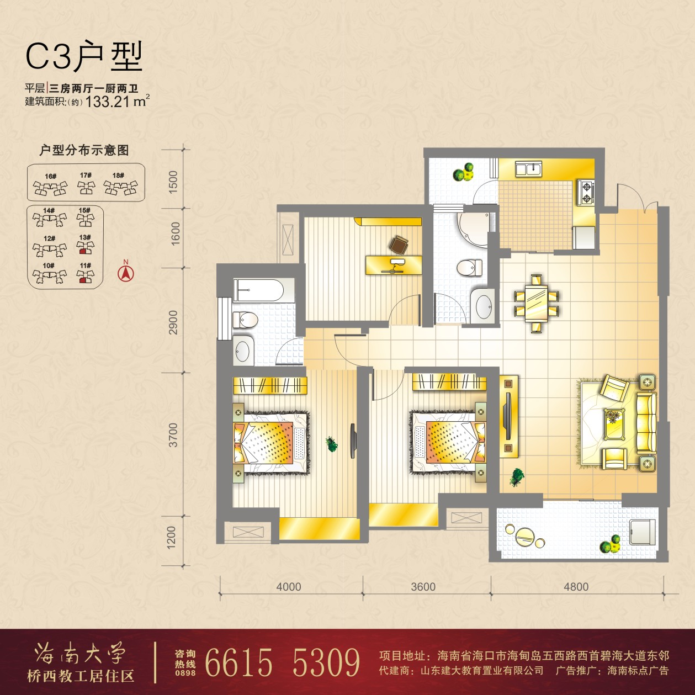
11号楼 | 13号楼
11-2504 | 13-2504
11-2404 | 13-2404
11-2304 | 13-2304
11-2204 | 13-2204
11-2104 | 13-2104
11-2004 | 13-2004
11-1904 | 13-1904
11-1804 | 13-1804
11-1704 | 13-1704
11-1604 | 13-1604
11-1504 | 13-1504
11-1404 | 13-1404
11-1304 | 13-1304
11-1204 | 13-1204
11-1104 | 13-1104
11-1004 | 13-1004
11-904 | 13-904
11-804 | 13-804
11-704 | 13-704
11-604 | 13-604
11-504 | 13-504
11-404 | 13-404
11-304 | 13-304
11-204 | 13-204
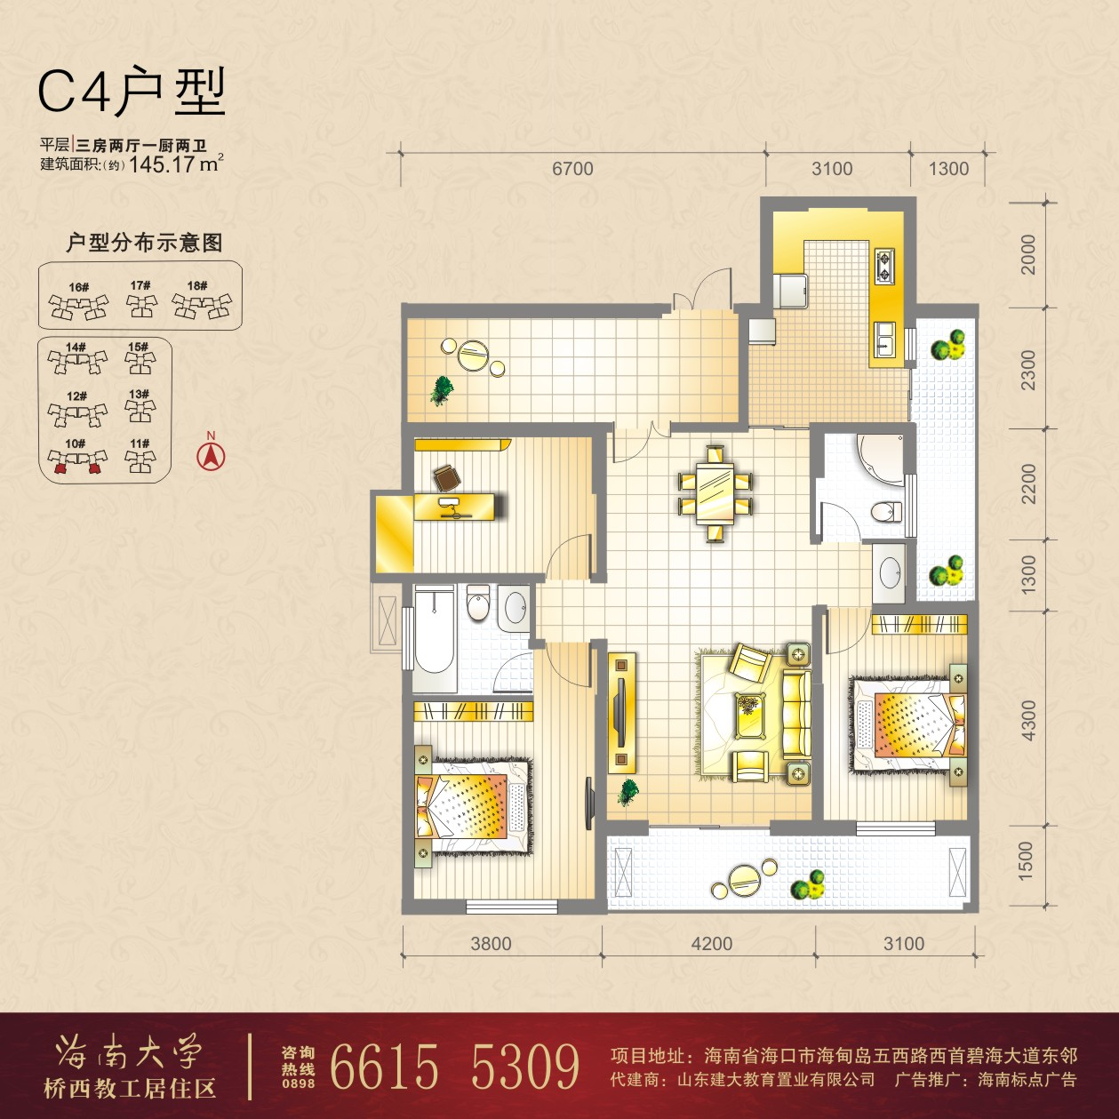
10号楼
10-A-1703 | 10-B-1703
10-A-1603 | 10-B-1603
10-A-1503 | 10-B-1503
10-A-1403 | 10-B-1403
10-A-1303 | 10-B-1303
10-A-1203 | 10-B-1203
10-A-1103 | 10-B-1103
10-A-1003 | 10-B-1003
10-A-903 | 10-B-903
10-A-803 | 10-B-803
10-A-703 | 10-B-703
10-A-603 | 10-B-603
10-A-503 | 10-B-503
10-A-403 | 10-B-403
10-A-303 | 10-B-303
10-A-203 | 10-B-203

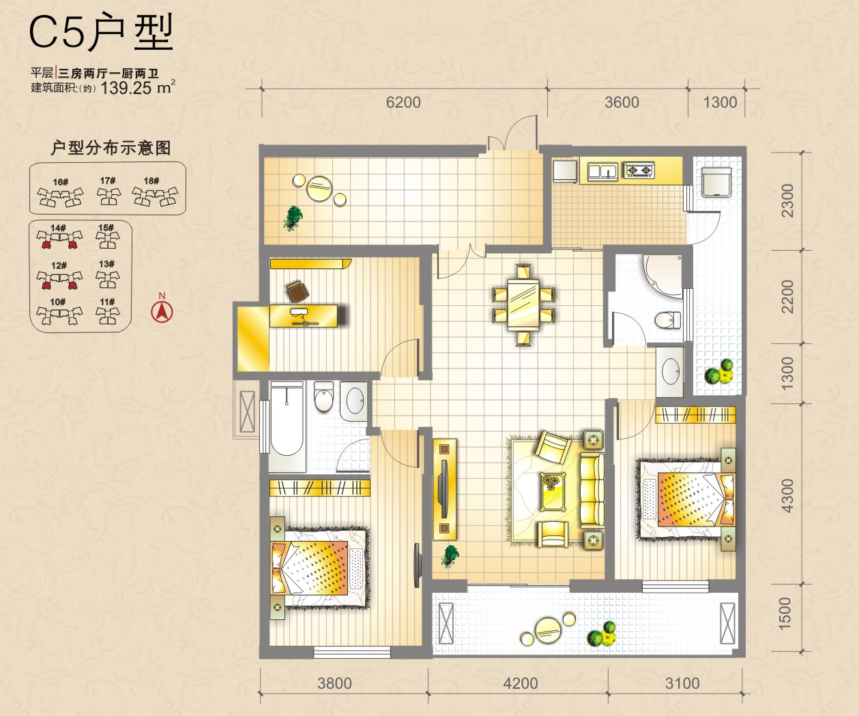
12号楼 |  | 14号楼
 |  | 14-A-2103 | 14-B-2103
 |  | 14-A-2003 | 14-B-2003
12-A-1903 | 12-B-1903 | 14-A-1903 | 14-B-1903
12-A-1803 | 12-B-1803 | 14-A-1803 | 14-B-1803
12-A-1703 | 12-B-1703 | 14-A-1703 | 14-B-1703
12-A-1603 | 12-B-1603 | 14-A-1603 | 14-B-1603
12-A-1503 | 12-B-1503 | 14-A-1503 | 14-B-1503
12-A-1403 | 12-B-1403 | 14-A-1403 | 14-B-1403
12-A-1303 | 12-B-1303 | 14-A-1303 | 14-B-1303
12-A-1203 | 12-B-1203 | 14-A-1203 | 14-B-1203
12-A-1103 | 12-B-1103 | 14-A-1103 | 14-B-1103
12-A-1003 | 12-B-1003 | 14-A-1003 | 14-B-1003
12-A-903 | 12-B-903 | 14-A-903 | 14-B-903
12-A-803 | 12-B-803 | 14-A-803 | 14-B-803
12-A-703 | 12-B-703 | 14-A-703 | 14-B-703
12-A-603 | 12-B-603 | 14-A-603 | 14-B-603
12-A-503 | 12-B-503 | 14-A-503 | 14-B-503
12-A-403 | 12-B-403 | 14-A-403 | 14-B-403
12-A-303 | 12-B-303 | 14-A-303 | 14-B-303
12-A-203 | 12-B-203 | 14-A-203 | 14-B-203

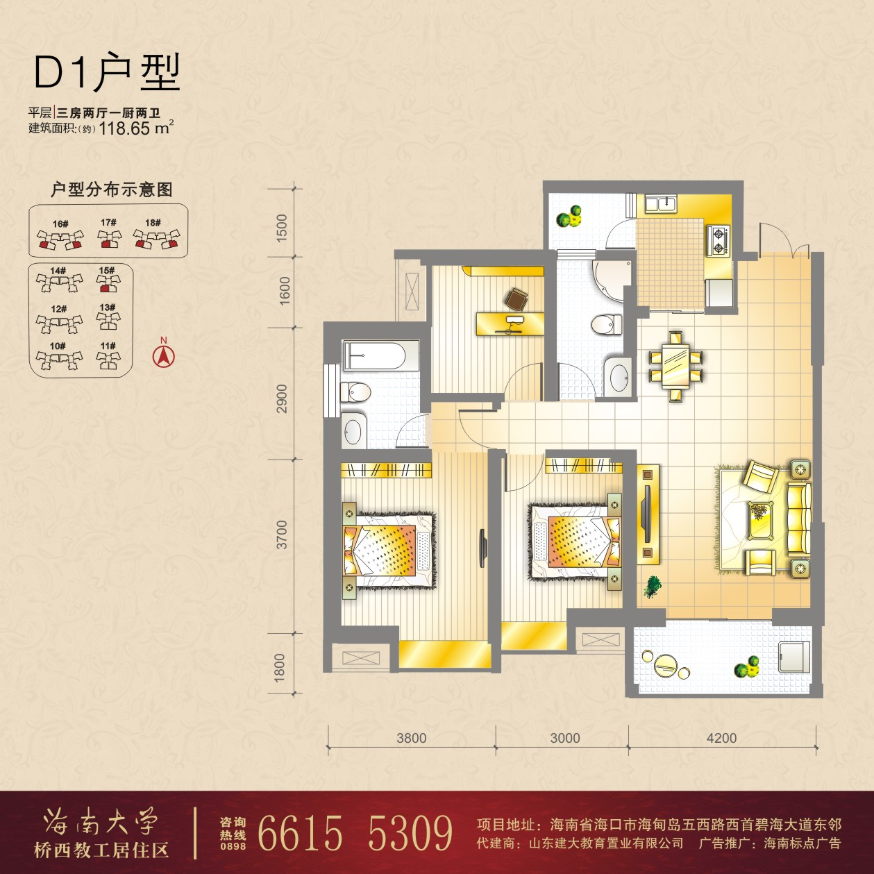
15号楼 | 16号楼 |  | 17号楼 | 18号楼
15-2504 |  | 16-B-2504 | 17-2504 | 18-A-2504 | 18-B-2504
15-2404 |  | 16-B-2404 | 17-2404 | 18-A-2404 | 18-B-2404
15-2304 |  | 16-B-2304 | 17-2304 | 18-A-2304 | 18-B-2304
15-2204 |  | 16-B-2204 | 17-2204 | 18-A-2204 | 18-B-2204
15-2104 |  | 16-B-2104 | 17-2104 | 18-A-2104 | 18-B-2104
15-2004 |  | 16-B-2004 | 17-2004 | 18-A-2004 | 18-B-2004
15-1904 |  | 16-B-1904 | 17-1904 | 18-A-1904 | 18-B-1904
15-1804 |  | 16-B-1804 | 17-1804 | 18-A-1804 | 18-B-1804
15-1704 |  | 16-B-1704 | 17-1704 | 18-A-1704 | 18-B-1704
15-1604 |  | 16-B-1604 | 17-1604 | 18-A-1604 | 18-B-1604
15-1504 |  | 16-B-1504 | 17-1504 | 18-A-1504 | 18-B-1504
15-1404 |  | 16-B-1404 | 17-1404 | 18-A-1404 | 18-B-1404
15-1304 |  | 16-B-1304 | 17-1304 | 18-A-1304 | 18-B-1304
15-1204 |  | 16-B-1204 | 17-1204 | 18-A-1204 | 18-B-1204
15-1104 |  | 16-B-1104 | 17-1104 | 18-A-1104 | 18-B-1104
15-1004 |  | 16-B-1004 | 17-1004 | 18-A-1004 | 18-B-1004
15-904 |  | 16-B-904 | 17-904 | 18-A-904 | 18-B-904
15-804 |  | 16-B-804 | 17-804 | 18-A-804 | 18-B-804
15-704 |  | 16-B-704 | 17-704 | 18-A-704 | 18-B-704
15-604 |  | 16-B-604 | 17-604 | 18-A-604 | 18-B-604
15-504 | 16-A-504 | 16-B-504 | 17-504 | 18-A-504 | 18-B-504
15-404 | 16-A-404 | 16-B-404 | 17-404 | 18-A-404 | 18-B-404
15-304 | 16-A-304 | 16-B-304 | 17-304 | 18-A-304 | 18-B-304
15-204 | 16-A-204 | 16-B-204 | 17-204 | 18-A-204 | 18-B-204
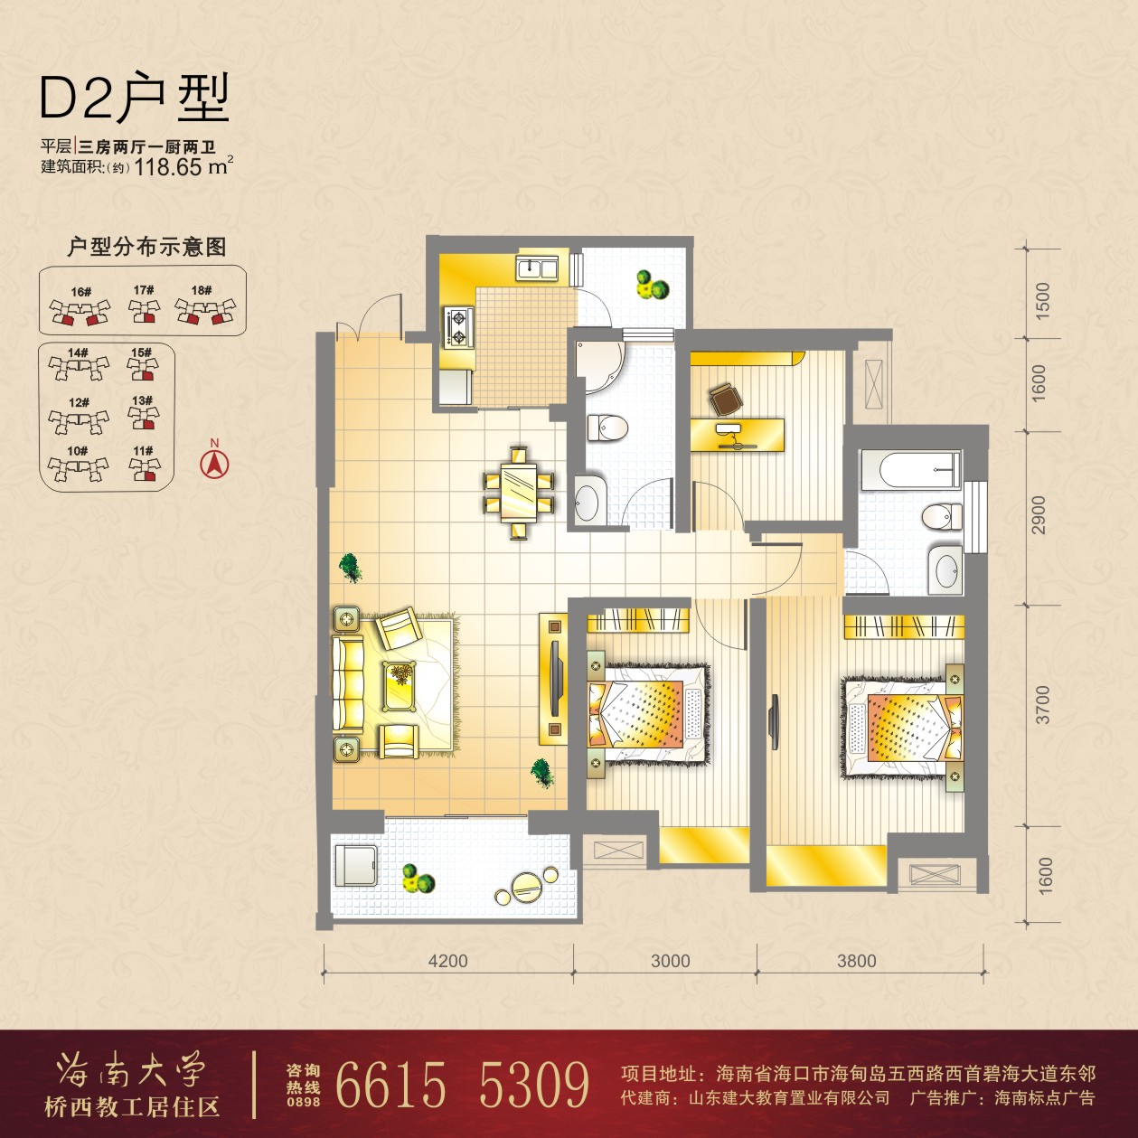
11号楼 | 13号楼 | 15号楼 | 16号楼 |  | 17号楼 | 18号楼
11-2503 | 13-2503 | 15-2503 | 16-A-2503 | 16-B-2503 | 17-2503 | 18-A-2503 | 18-B-2503
11-2403 | 13-2403 | 15-2403 | 16-A-2403 | 16-B-2403 | 17-2403 | 18-A-2403 | 18-B-2403
11-2303 | 13-2303 | 15-2303 | 16-A-2303 | 16-B-2303 | 17-2303 | 18-A-2303 | 18-B-2303
11-2203 | 13-2203 | 15-2203 | 16-A-2203 | 16-B-2203 | 17-2203 | 18-A-2203 | 18-B-2203
11-2103 | 13-2103 | 15-2103 | 16-A-2103 | 16-B-2103 | 17-2103 | 18-A-2103 | 18-B-2103
11-2003 | 13-2003 | 15-2003 | 16-A-2003 | 16-B-2003 | 17-2003 | 18-A-2003 | 18-B-2003
11-1903 | 13-1903 | 15-1903 | 16-A-1903 | 16-B-1903 | 17-1903 | 18-A-1903 | 18-B-1903
11-1803 | 13-1803 | 15-1803 | 16-A-1803 | 16-B-1803 | 17-1803 | 18-A-1803 | 18-B-1803
11-1703 | 13-1703 | 15-1703 | 16-A-1703 | 16-B-1703 | 17-1703 | 18-A-1703 | 18-B-1703
11-1603 | 13-1603 | 15-1603 | 16-A-1603 | 16-B-1603 | 17-1603 | 18-A-1603 | 18-B-1603
11-1503 | 13-1503 | 15-1503 | 16-A-1503 | 16-B-1503 | 17-1503 | 18-A-1503 | 18-B-1503
11-1403 | 13-1403 | 15-1403 | 16-A-1403 | 16-B-1403 | 17-1403 | 18-A-1403 | 18-B-1403
11-1303 | 13-1303 | 15-1303 | 16-A-1303 | 16-B-1303 | 17-1303 | 18-A-1303 | 18-B-1303
11-1203 | 13-1203 | 15-1203 | 16-A-1203 | 16-B-1203 | 17-1203 | 18-A-1203 | 18-B-1203
11-1103 | 13-1103 | 15-1103 | 16-A-1103 | 16-B-1103 | 17-1103 | 18-A-1103 | 18-B-1103
11-1003 | 13-1003 | 15-1003 | 16-A-1003 | 16-B-1003 | 17-1003 | 18-A-1003 | 18-B-1003
11-903 | 13-903 | 15-903 | 16-A-903 | 16-B-903 | 17-903 | 18-A-903 | 18-B-903
11-803 | 13-803 | 15-803 | 16-A-803 | 16-B-803 | 17-803 | 18-A-803 | 18-B-803
11-703 | 13-703 | 15-703 | 16-A-703 | 16-B-703 | 17-703 | 18-A-703 | 18-B-703
11-603 | 13-603 | 15-603 | 16-A-603 | 16-B-603 | 17-603 | 18-A-603 | 18-B-603
11-503 | 13-503 | 15-503 | 16-A-503 | 16-B-503 | 17-503 | 18-A-503 | 18-B-503
11-403 | 13-403 | 15-403 | 16-A-403 | 16-B-403 | 17-403 | 18-A-403 | 18-B-403
11-303 | 13-303 | 15-303 | 16-A-303 | 16-B-303 | 17-303 | 18-A-303 | 18-B-303
11-203 | 13-203 | 15-203 | 16-A-203 | 16-B-203 | 17-203 | 18-A-203 | 18-B-203

