*Please Choose a Topic*

**Conference topics:**

* Choice 1:
* Choice 2:

**Main topics of the conference are:**

A) New energy materials & evaluations

B) Biomaterials & biomimetic materials

C) Nanomaterials & devices

D) ecological materials & Porous materials & marine materials

E) New processes and technology of material fabrication

**Keywords (Please provide up to 5 keywords)**

* Keyword 1:
* Keyword 2:
* Keyword 3:
* Keyword 4:
* Keyword 5:

**Presentation form:**

* Choice 1 oral or 2 poster:

1. **For oral presentation:** abstract template in next page.
2. **For poster presentation:** poster pannel size: 90cm X 120cm (Width X Length)

**Title in Times New Roman 14 point – Upper and Lower Case**

A.B. Author 1, C.D. Co-Author 2, E.F. Co-Author 1 (Times New Roman, 10.5pt; regular, presenting author underlined)

1Department1, Institution1, Address1, City1, Country1 (Times New Roman, 10.5pt, italic)

2Department2, Institution2, Addres2, City2, Country2  
email: (only for the presenting author)

Abstract:

This is an abstract template for the 17th International Symposium on Eco-materials Processing and Design (ISEPD-2016) to be held from 8-11 January, 2016 in Haikou, China. To maintain a coherent layout of the proceedings, all authors should kindly write the abstracts using this template provided in the conference web pages. The abstract should be prepared in English language and not exceed **ONE A4 PAGE**.

Times New Roman font and single-spaced lines are adopted although the abstract. The title is in 14-point boldface, the author(s) name(s) is in 10.5-point regular, the affiliation(s) and address(es) is in 10.5-point italic, and the main text (including tables and figures captions, keywords, references) is in 10.5-point regular.

Tables and figures can be included in your abstract, such as the blue sky of Hainan University in Fig. 1. Figures should be inserted directly to the document and their positions should be adjusted properly. Accepted abstracts will be published as they are in the Meeting´s Book of Abstracts.

Footnotes (if any) should be located at the end of abstract. References are cited in the text like this [1]. The reference list should use the format shown at the bottom of the page.

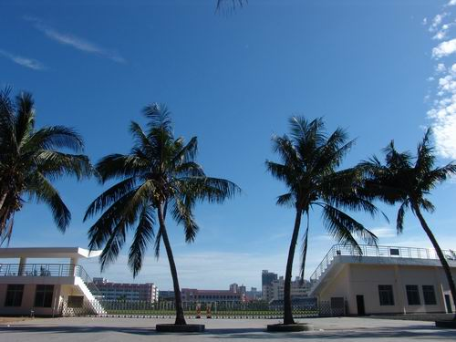

**Fig. 1** An example figure: the blue sky of Hainan University.

**Keywords:** *****, *****, *****, *****, *****

References:

[1] T. Sasaki et al., Nat. Mater. 12, 569-575 (2013)

[2] E. Madej et al., Adv. Energy Mater. 4, 1400829 (2014)